Master Document – Team Mock Sprint (Login Restyling)

Role | Date
BA – Ming Yan Tan | Tuesday, 4 August 2026

1. Features overview
- To build following features for the existing boilerplate.
  - A styled login page
  - A team page showing the following items
    - Team name
    - Each member’s:
      - Photo
      - Name
      - Role
      - Short blurb

2. Scope

2.1 In scope
- Restyle the existing login page of the existing boilerplate with UX provided design.
- Retain the existing login fields which uses Email and Passwords.
- Retain control and authentication flow.
- Create a new team page.
- Configure successful login navigation so that user is directed to the team page.
- Display the team name and profile section for each team members.
- In each profile section, show each member’s photo, name, role, and short blurb.

2.2 Out of scope
- Changes to the authentication logic, credential validation, session creation, session expiry or logout behaviour.
- New registration, password reset, account recovery or role/permission features.
- Changes to the existing database, identity provider or back-end services solely for this restyling task.
- Additional pages or features beyond the login page and team page.

3. Team page content fields and display rules
Field | Requirement | Proposed validation | Display rule
Team name | Required | Plain text | Shown as the main heading. Must wrap on small screen and doesn’t overlap with other content.
Member photo | Required | Image file | Displayed consistently with team member entry.
Member name | Required | Plain text | Show under member photo.
Member role | Required | Plain text | Show under member name.
Short blurb | Required | Plain text | Show under member role.

4. Edge Cases
Scenario | Expected behaviour
Missing member photo | Show placeholder image, the member details remain visible.
Broken or unsupported photo | Treat it as a missing photo and show a placeholder.
Long member name | Wrap the text.
Long member role | Wrap the text.
Longer than expected blurb text | Wrap the text.
Blank required field | Do not publish the incomplete entry until all required fields are filled.
Invalid login | Existing authentication failure behaviour remains unchanged, only styling changes.

5. Assumptions
- The existing boilerplate already contains a working login flow.
- The team will supply final text and photos before implementation is completed.
- The login restyling can be completed without changing authentication or session code.
Handoff notes
- Done: Created Login Restyling.docx and updated all the required information for UX design
- Deliverable: Master Document - Team Mock Sprint
- Note for next roles: For assumptions made, refers to section 5. Assumptions in Login Restyling.docx

Role | Date
UX – Jamie Rottura | Wednesday, 5 August 2026

6. Mock-ups
Login page:
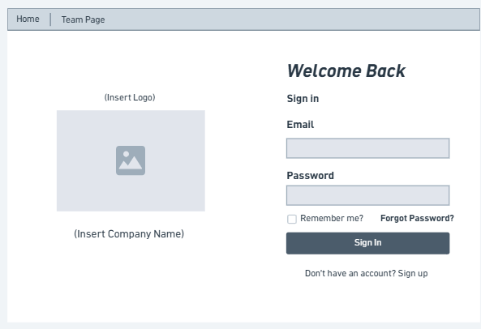
Login Page (Edge Cases):
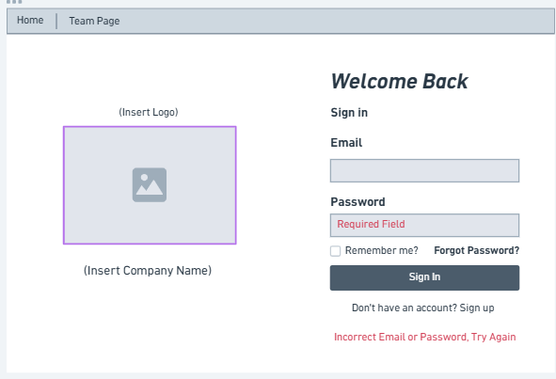

Team Page:
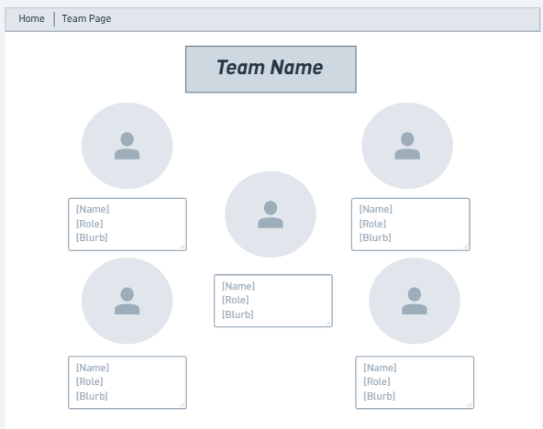
Team Page (Edge Cases):
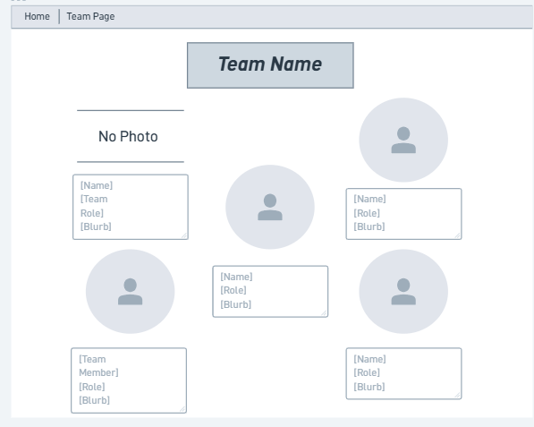
Colours in document:
Input fields: HEX #DCE5ED
Header/navigation: HEX #C9D6DF

Handoff notes
- Done: Created 4 mockups for Login and Team member page, each page has the base mockup, and the 2nd mockup shows the edge cases for that page.
- Notes: BA to check over mockups and approve designs to fit the requirements.

Role | Date
BA – Ming Yan Tan | Thursday, 6 August 2026

7. Approved Design Decisions
- Team page will use member cards.
- Member card will display photo, name, role, and short blurb.
- A default placeholder will be in place if member photo is not available.
- Long blurb will be wrapped within the box.
- The existing login fields (email & password) and login button will be retained.
- Successful login will navigate to “Team” page.

8. Content requirements
Field | Requirement | Final content
Team name | Displayed as the page heading | Plain text, [Team name]
Member photo | One image per member | Image file
Member name | Full Name | Plain text, [Names]
Member role | Project role | Plain text, [Roles]
Short blurb | Short personal introduction | Plain text, [Blurb]

Handoff notes
- Done: Updated Login Restyling.docx and approved UX mockup design
- Deliverable: Master Document - Team Mock Sprint
- Note: If there is any change to the approved design or requirements after development begins, contact BA and PM before implementation.

Role | Date
Developer – Perry Tsironis | Monday, 10 August 2026

9. Implementation Notes: Build Team Page & Auth Redirect

- Team page built using a flexbox-based layout (two-column stacks on either side with a centre card vertically aligned between them) matching the approved mock-up layout in section 6.
- Member cards each display member photo, name, role, and blurb per the approved content requirements in section 8.
- Missing team member photos use a placeholder.svg image consistent with edge cases defined in section 4.
- Successful login through email/password and Google redirect to the ‘Team’ page, as specified in section 7.
- Team page is inaccessible without a valid session
- No changes were made to existing authentication logic, session behaviour or credential validation, consistent with out-of-scope items in section 2.2.
- Team page and shared navigation restyled to match the approved light-theme colour palette shown in section 6 wireframe – previously implemented using boilerplate’s default dark theme
- Sidebar removed from DashboardShell and its links (Dashboard, Team, Notes, Profile, Settings) folded into a single restyled top navigation bar matching wireframes' navbar shape.
Handoff Notes
- Done: Implemented the team page and login redirect per the approved design; updated this document with implementation notes.
- Deliverable: Feature/team page by s4146473 · Pull Request #1 · NguyenQuangMinhe/garage-boilerplate-basic
- Note:
  - Team member data stored in frontend/src/app/(dashboard)/team/team-data.tsx
  - Team member photos and placeholder.svg stored in frontend/public/team
  - Dashboard restyling (sidebar removed) affects all dashboard pages (Dashboard, Notes, Profile, Settings), not just Team. Only Login and Team page were in scope, so other pages were not otherwise updated to match new styling and therefore contain boilerplate dark-theme styling.
Role | Date
Developer – Nguyen Quang Minh | Tuesday, 11 August 2026

10. Implementation Notes: Apply the approved visual design to the existing login page in the boilerplate. Do not modify the authentication logic, validation, or session handling

- Login page built using a flexbox-based layout to mostly centre elements and grid to make 2 columns of image and login input and details.
- Error handling UX design done according to wireframe, showing required fields to be filled and an error message
- Login logic still uses same redirection logic, validation logic and error handling
- Logo and company name is still currently using placeholders
- No changes were made to existing authentication logic, session behaviour or credential validation, consistent with out-of-scope items in section 2.2.
Handoff Notes
- Done: Implemented the login page design and error handling per the approved design; updated this document with implementation notes.
- Deliverable:

11. Test Login -> Redirect -> Team Page Flow

Role | Date
Developer – Perry Tsironis | Thursday, 13 August 2026

Testing Notes: Valid Login End-to-End
- Tested on test/combined branch (merge of feature/team-page and feature/login) via localhost:3000, as deployment not yet completed at time of testing
- Entered valid credentials via redesigned Login Page (email/password): login was successful and success notification accurately displayed.
- Entered invalid credentials via Login Page (email/password): login was successfully prevented, error display issue found (see ‘Steps to Reproduce’ section below)
- No issues identified in login-flow
Test: Login page contains all required content verified correct and complete checklist
Required Content | Present and Matching Wireframe
Logo placeholder + “insert logo” label | Yes
“Insert Company Name” label, placement below “Logo” placeholder | Yes
“Welcome Back” heading | Yes
“Sign In” subheading | Yes
Email field with accurate label | Yes
Password field with accurate label | Yes
“Remember me?” checkbox | Yes
“Forgot Password?” navigation link | Yes
“Sign In” form completion button | Yes
“Don’t have an account? Sign Up” Navigation link | Yes
Error state: “Required field” text on submit attempt with empty input | Yes
Error State: “Incorrect Email or Password, Try Again” on submit attempt with incorrect input field | No

Error State: “Incorrect Email or Password, Try Again” on submit attempt with incorrect input field.
Steps to Reproduce:
- Navigate to /auth/signin
- Enter an incorrect email/password combination
- Submit
Expected: Displayed below Sign In button: In-page red text “Incorrect Email or Password, Try Again” below “Sign In” button (as per section 6 wireframe)
Actual: Temporary pop-up notification: “Invalid Email or Password” appears in top-left corner. Accurate in-page error message exists yet tied to empty sign in form inputs.

Role | Date
Developer – Nguyen Quang Minh | Thursday, 13 August 2026

Test: Redirect to Team Page
- Tested on test/combined branch (merge of feature/team-page and feature/login) via localhost:3000, as deployment not yet completed at time of testing
- Log in flow completed with correct email and password
- Correctly verified that it automatically redirects to team page after logging in
Test team page contains all required content verified correct and complete
- Images: Contains all of team member’s images in files system and displayed correctly in page, place holder included also for unavailable statuses
- Names: listed correctly and adequately for all members in code and displayed
- Roles: listed correctly and adequately for all members in code and displayed
- Blurb: listed correctly and adequately for all members in code and displayed
Required Content | Present and Matching Wireframe
Navigation bar with all tabs including Team | Yes
Team name label with appropriate design choice | Yes
Each member in designed card format | Yes
Images for every member | Yes
Placeholder image | Yes
Member names | Yes
Member roles | Yes
Member blurbs | Yes

Notes:

12. Testing: Edge cases and log bugs
Role | Date
Developer – Nguyen Quang Minh | Thursday, 13 August 2026

Bug logging:
- Missing-photo and long blurb not yet implemented, has been implemented by Nguyen Quang Minh by use of || conditional for image, line-clamp-3 and passed over to Perry Tsironis to test
Fix: Error text now included for all states: missing email and password and incorrect email and password by using a state function
Error State: “Incorrect Email or Password, Try Again” on submit attempt with incorrect input field | Yes

Test: Direct team-page access without login tested (must redirect)
- Tested in environment where user is not yet logged in
- “/team” URL is directly accessed to test redirection
- Successfully redirects back to log in section for user to fill in details
Handoff Notes
- Done: Implemented missing-photo and long blurb handling

Role | Date
Developer – Perry Tsironis | Thursday, 13 August 2026

Test Edge Case: Invalid Login
- Invalid Login Tested: see section 11 (“Testing Notes: Valid Login End-to-End") for full repro steps.
- Summary: Invalid credential login attempts are accurately prevented, however error display does not match approved design.
Test Edge Case: Missing Photo and Long Blurb
- Tested missing photo-fallback: temporarily removed a team member’s image from team-data.tsx. Card correctly displayed placeholder.svg fallback, with all member details: name, role, blurb, remaining visible
- Tested long-blurb wrapping: temporarily extended a team member’s blurb to several sentences beyond prior-testing length. Card correctly wrapped and extended to accommodate for the new blurb length. No overlapping for neighbouring cards.
- No issues found – both implementations accurately meet the documented edge cases (section 4).

12. Deployment
Role | Date
Developer – Nguyen Quang Minh | Thursday, 13 August 2026
Deployment completed via boilerplate pipeline
- Added github repo to Vercel, root directory as frontend folder and all required environment variables including API key and encoded service key
- Finally deployed it to vercel
Live URL loads without errors
- Tested access at https://garage-boilerplate.vercel.app
- URL loads fully as intended from local testing
Login → redirect → team page flow spot-checked on the deployed URL
- Tested with account details as signed up and stored in firebase
- Account access successful
- Redirected to team page
- Flow verified
Handoff Notes
- Done: Fully completed features, testing and deployed to live URL as discussed and shown in documentation and planner
- Deliverable: https://garage-boilerplate.vercel.app

13. Final Approval
Role | Date
Project Manager – Reese Paull | Sunday, 16 August 2026

Done:
- Verified all prior checklists are completed.
- Features approved.
- Verified that the prior deliverables exist and work.

